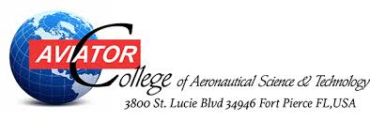
Achievement Scholarship

Sponsored by: Aviator College of Aeronautical Science & Technology
Contact: Aviator College of Aeronautical Science & Technology
3800 St. Lucie Boulevard, Fort Pierce, Florida 34946
When can you apply: Once you have completed your end of course for Commercial.
Amount Awarded: Up to $5,000 to be paid out over subsequent ratings or semesters as recipient maintains scholarship criteria.

Scholarship Criteria:
- Must be a current Aviator College student
- FAA Examination score 90% or higher, first time pass.
- Cumulative GPA of 3.4 or higher.
- Copy of log time towards Private Pilots License. Rating Earned within 110% of FAA Minimum hours, verified with log-book and ACMS flight hour records.
- 500 word essay describing why you chose Aviator College to study aviation
- 2 letters of recommendation: 1 from an Aviator instructor, 1 from outside individual
- The scholarship will only be awarded to the student upon completion of the single and multi commercial licenses.

Selection will be based on academic excellence, flight time completion hours, and overall qualities. Recipient will be notified within 30 days of application submittal.
Award is contingent on recipient maintaining satisfactory academic progress and good standing within the College.

Achievement Scholarship Application

Name: Student #:

Start Date: Anticipated Graduation/Completion Date:

Cumulative GPA: FAA Test Scores Attached:

Total hours flown for Private Pilot License Completion:

Copy of log book attached:

Copy of Essay Attached:

Letters of Recommendation attached from:

- Aviator Flight Instructor Name:

Ratings completed with this Instructor:

- Name: Relationship:

Job title: Years known:
For Office Use Only

Date Application Received:

